Cloud Exploitation to Secure Design, the SnapVault Project
UTS 43001 Cybersecurity Challenge Studio, Industry Stream · Aziz Almehmadi, Abdulrahman Albrahim, Nawaf Alanazi · Oct 17, 2026

1. Executive Summary
Most cloud breaches are not the work of one clever exploit. They are built from a few small misconfigurations that happen to line up. A secret left where a user can read it, an identity handed more access than its job calls for, a storage system wired to a web server that will run whatever it finds. That is roughly the sequence Capital One suffered in 2019, and it is the sequence this project reproduces eight times across Hack The Box's Cloud Exploitation track.
The report pulls together four connected pieces of work. The first is a full set of walkthroughs for all eight machines, SteamCloud, Epsilon, Gobox, Bucket, Worker, Monteverde, Vessel, and Unobtainium, and each one carries its own root cause, its fix, and a link back to our own build rather than stopping at the flag. The second is SnapVault, a small file-sharing service we built twice from a single code base, once deliberately weak and once hardened, so the same attack can run against both while configuration is the only thing that changes. The third is an AI agent, locked to the local loopback interface, that replays the full six-step SnapVault chain in about two minutes on the weak build and is stopped at the first step on the hardened one. The fourth is a developer guideline of seven controls, C1 to C7, that turns every lesson from the eight machines into a checklist, with each control tied back to the machine that showed why it matters.
All eight machines are finished. SnapVault's two environments are built and tested side by side, the agent demo runs end to end on both, and the guideline is done. The one thing we left out on purpose, explained in the Limitations section, is a version of the agent pointed at a developer's own cloud service instead of our local lab.

2. Industry Problem and Real-World Context
The pattern behind most newsworthy cloud incidents is misconfiguration, not some new exploit. A credential lands where it should not sit, an identity reaches further than its job needs, and a service treats user-controlled storage as something safe to run. Any one of these is survivable on its own. Chained together they are not.
Capital One in 2019 is the clearest public case. An attacker used a server-side request forgery flaw in a misconfigured web application firewall that sat in front of Capital One's AWS environment. That flaw reached the EC2 instance metadata service and pulled the temporary credentials of an IAM role, and the role had far more access than the firewall itself needed, including read access to a large set of S3 buckets. From there the attacker listed and downloaded data on roughly 100 million customers. Nothing in that chain was exotic. A misconfigured edge service, an over-permissioned role, and storage that trusted the role too much were enough on their own.
The fallout made the same point. The U.S. Office of the Comptroller of the Currency fined the bank 80 million US dollars, finding it had not assessed the risk of its cloud migration or closed known gaps in time, on top of the cost of notifying and supporting the roughly 100 million people affected. The wider numbers tell the same story. Cloud misconfiguration regularly ranks among the most common initial attack vectors in breach research, and a cloud breach now costs organisations more on average than one kept to on-premises systems. None of that cost came from a zero-day. It came from the same three ingredients this project keeps meeting across eight HTB machines, a credential somewhere it should not be, a role that can do more than its job requires, and a storage layer that trusts both too much.
This is the shape the project tests eight times over. Each machine on the Cloud Exploitation track rebuilds one or two links of that chain in a new setting, a key leaked in client code, a token that reaches too far, a storage layer that lets a web server run what gets written to it, a container or pod with more privilege than its job needs. It matters in practice because these are not research-grade bugs. They are the small, unglamorous gaps a development team can introduce without anyone noticing, until an attacker strings three or four of them together, which is exactly what happened at Capital One and exactly what SnapVault is built to show and then close.

3. Market, User, and Stakeholder Analysis
Three groups get something useful out of this project, and each wants a different output from the same material.
Cloud developers are the main audience for the guideline. They write the upload handler, pick the IAM policy, and decide whether a bucket needs versioning, usually with no security specialist reviewing every call. Today they work from general cloud-provider documentation and whatever conventions the team already has, which rarely ties a specific coding choice to a specific attack. The guideline gives them seven numbered controls, each with a concrete requirement, a short list of practices, and a check they can run themselves before a reviewer ever sees the code. SnapVault's C1 and C4, for example, turn "don't leak secrets" and "validate uploads" from general advice into a literal line of code they can hold their own app against.
Cloud and DevOps engineers care about the SnapVault architecture more than the walkthroughs. They are the ones who set container privileges, network exposure, and bucket policy at deploy time, and the side-by-side weak and hardened builds give them a real before-and-after instead of an abstract hardening list. A DevOps engineer weighing up whether to turn on bucket versioning can see straight in Section 8 what that one setting cost the vulnerable build.
Students and junior penetration testers, our own team at the start of this track included, are the audience for the eight walkthroughs. Public write-ups for these machines exist, but nearly all of them stop at the flag. A junior tester learns how to get the shell without necessarily learning why the misconfiguration was there or what a fix looks like in real code, and that is the gap our walkthroughs close by carrying every machine through to a root cause, a fix, and a mapped control. The difference matters for a career, not just a grade, since being able to explain what caused a finding and what fixes it is what separates a report a client can act on from one they file away.
The constraint is the same for all three. Nobody in these roles has time to read a full penetration test report before making a call, so the guideline and the comparison documents are built to be skimmed and checked against rather than read end to end.

4. Existing Solutions and Gap Analysis
Three kinds of material already cover parts of this ground, and each one stops short somewhere.
Public Hack The Box write-ups for these eight machines are easy to find, and most handle the technical path to root well. Almost none go further. The write-up ends at the flag, with little or no account of why the misconfiguration existed, what an organisation would actually change, or how the finding carries beyond that one box. A reader finishes knowing how to exploit SteamCloud in particular, not what an unauthenticated Kubelet means for any cluster.
Cloud-provider hardening documentation, from AWS, Azure, and the rest, is thorough but generic. It has to cover every customer's configuration at once, so it rarely says which exact combination of settings becomes a working attack chain, and it gives you no way to test whether a given fix really closes the hole short of building a lab yourself.
Commercial cloud security posture tools exist too, and they are good at flagging a single misconfiguration against a ruleset. What they do not do is show a developer the end-to-end result, that a hardcoded key plus an over-scoped read policy plus an executable upload path chains into root, and they do not teach the underlying pattern in a way a junior engineer can carry to the next project.
The gap is the link between those three. There is attack detail with no lasting guidance, guidance with no attack detail, and detection with no story. Our track-to-lab-to-guideline pipeline is built to close it. Eight machines each explained past the flag, one small application built twice so the same chain is provably stopped by specific, testable controls, and a guideline that traces every control back to the machine that justified it. The contribution is not a new scanner or a new exploit. It is a working, repeatable link between seeing a class of vulnerability and knowing exactly what stops it.

5. Project Scope
In scope. Full walkthroughs of all eight Hack The Box Cloud Exploitation machines, each with enumeration, exploitation, root cause, fix, and a mapped link to SnapVault. SnapVault itself, a MinIO-backed file-sharing app built as two Docker Compose stacks, vulnerable and hardened, from one code base. A documented end-to-end attack chain run by hand against the vulnerable build and confirmed blocked on the hardened one, with the architecture, identities, and configuration differences between the two spelled out. A local AI agent, hard-locked to loopback, that replays the same chain against both builds and reports an honest pass or fail. And a seven-control developer guideline, C1 to C7, drawn straight from the eight machines and the SnapVault build, with a requirement, practices, and a check for each control.
Out of scope. This is not a commercial product and not a benchmark against existing scanners. It is a learning resource for the stakeholders in Section 3. SnapVault is one part of the project rather than the whole of it, so the report does not treat "we built SnapVault" as the deliverable on its own. No real-world target, cloud account, or organisation is tested anywhere, only HTB's lab and our own local containers. The agent is a local demo, not a general penetration testing product, and a developer-facing version of it is future work, covered in Section 13.
Assumptions and constraints. The project assumes a reader with some cloud and web application background, so the guideline is pitched at that level rather than at a complete beginner. It was built and tested on one laptop-scale Docker Compose setup rather than a managed cloud account, which keeps the comparison controlled but means some findings, particularly around IAM, stand in for a full cloud provider's identity system in simplified form. The three of us split the eight machines and the write-up and build work, set out by name in Section 10.

6. Requirements and Success Criteria
Technical requirements. The vulnerable and hardened builds had to run from the same application code so that configuration, not functionality, was the only variable. Both had to be reproducible from a clean docker compose up, with the attack chain runnable either through a documented manual walkthrough or through the automated agent. The agent had to be restricted to loopback addresses only, with no route to a real network target, and had to produce a truthful, unedited transcript of each step rather than a scripted-looking success. Reproducibility had a literal bar too. A teammate who had not built a given machine's exploit needed to follow the published walkthrough and reach the same foothold, because a step only one author could repeat was not yet a finished walkthrough.
Practical requirements. Every walkthrough had to make sense to a junior analyst, not only be repeatable by whoever wrote it, so each one carries an explicit root cause and fix rather than a bare command sequence. Every finding had to map to a specific, testable control instead of a vague recommendation, so a code reviewer could check a build against the guideline the same way our hardened SnapVault passes it. All testing stayed inside HTB's lab or our own containers, with nothing aimed at a system we did not own or were not authorised to test. Where HTB's terms set a boundary, around scope or data retention for instance, those terms won over any convenience a wider test might have offered.
Success criteria.
- All eight machines rooted and documented, each with a working root cause and fix.
- The vulnerable SnapVault build falls to the documented chain, ending in code execution.
- The hardened SnapVault build blocks the same chain, checked at the exact step each control is meant to stop.
- The AI agent reproduces both outcomes with no manual help and refuses any non-loopback target.
- Every one of the seven controls is backed by at least one named machine, so no control is guidance without evidence.

7. Proposed Solution and Technical Workflow
The project runs one pipeline, eight times for the HTB track and once more for SnapVault, then folds everything into a single guideline at the end.
- Work the machine. Enumerate, find the foothold, and escalate to full compromise, keeping every command and screenshot as evidence.
- Identify the root cause. Name the specific misconfiguration behind the box, not just the technique used against it, a key hardcoded in client-side code rather than "found a credential."
- Write the fix. Say what a development or operations team would change, in terms specific enough to check, not a general nudge to "follow best practice."
- Map it to a control. Set the root cause and fix against one of the seven controls, so the lesson outlasts the single machine it came from.
- Carry it into SnapVault. Where a control fits our own build, implement it in the hardened stack and deliberately leave its opposite in the vulnerable stack, so the lesson becomes something an attacker can fail against rather than only a written rule.
- Prove it both ways. Run the same attack chain against both builds, by hand first and then through the agent, and record exactly where the hardened build stops it.
- Publish the guideline. Fold every control that survived step 6 into the developer guideline, with each entry naming the control, the requirement, the practices that meet it, and the check a reviewer runs to confirm it.
The same seven steps hold whether the source machine was a Linux web app, a Kubernetes cluster, or a Windows domain controller, which is what let three of us work different machines in parallel and still land on one consistent guideline rather than eight disconnected write-ups. In practice the pipeline also carried a review step the list above leaves out. Before a root cause and fix moved into the guideline, at least one other team member checked that the mapped control really matched what the machine showed, rather than trusting the original author's call. That cross-check caught a handful of early mismatches. One early draft mapped Worker to C4, upload handling, when its root cause sat entirely in C7, secrets in version control, and the review fixed it before it reached the guideline.

8. System Architecture and Implementation Design
Both builds run the same three containers on one Docker network. app (Apache, PHP, and the mc client serving the site), minio (the S3-compatible object store, with the API on port 9000 and the console on 9001), and minio-init (a one-shot container that creates the bucket, identities, and seed data). The application code is the same in both builds. What changes is how each piece is exposed and privileged.
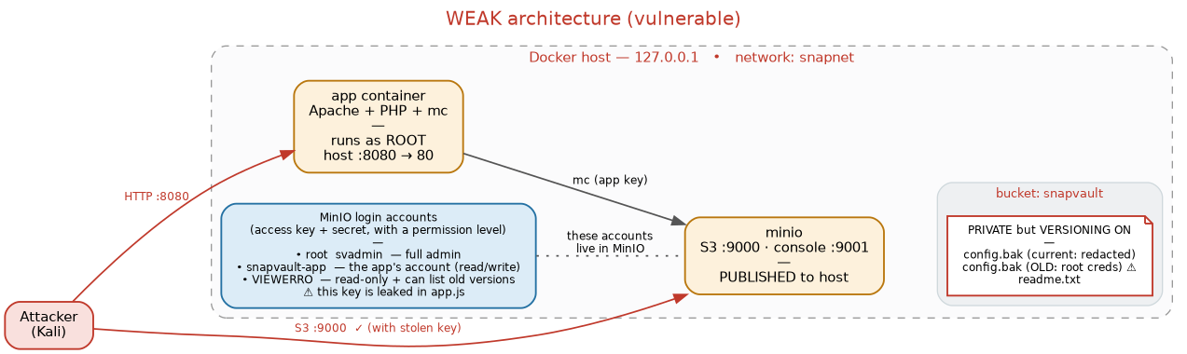
In the vulnerable build the app container runs as root on port 8080 with nothing locked down, and MinIO publishes both 9000 and 9001 straight to the host, so the storage API is a direct target for anyone who reaches the box.
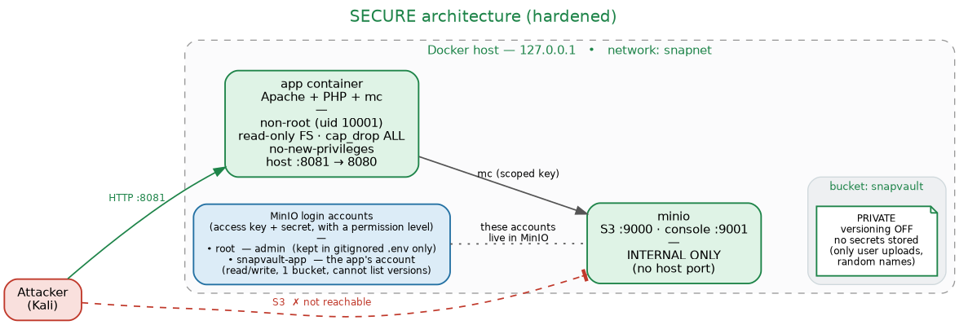
In the hardened build the app runs as a non-root user (UID 10001) on port 8081, with a read-only root filesystem, every capability dropped, and no-new-privileges set. MinIO is reachable only over the internal Docker network and never from outside the host.
Four implementation details carry most of the weight.
- Identities. The vulnerable build hardcodes a read-only viewer key in the frontend app.js, and that key's policy is over-scoped so it also allows s3:ListBucketVersions. The hardened build ships nothing to the browser and gives the app one scoped service account limited to GetObject, PutObject, and ListBucket on a single bucket.
- Versioning. The vulnerable bucket has versioning turned on, and an old config.bak object still holds admin credentials inside an earlier version, recoverable even after the live file looks clean. The hardened bucket has versioning off and holds no secret of any kind.
- Uploads and serving. The vulnerable app runs mc mirror on every page load, copying the whole bucket into the Apache web root, where +ExecCGI lets PHP run. The hardened app only lists object names and streams each file back with Content-Disposition: attachment, so nothing written to the bucket ever lands in an executable path, and uploads are held to an allow-list of safe types with server-generated random filenames.
- Secrets and version control. The vulnerable build commits a .env file with live credentials. The hardened build keeps every secret in an untracked .env, ships only a .env.example template, and stores the admin password as a bcrypt hash rather than plaintext.
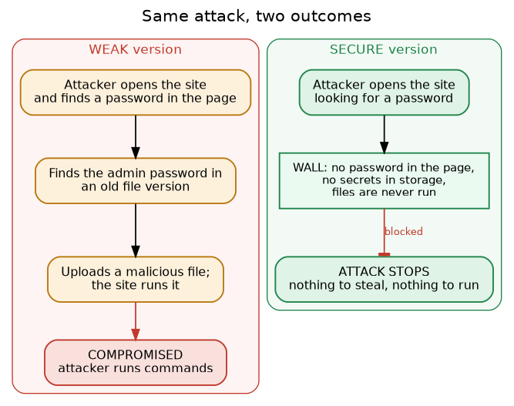
Aspect | Vulnerable build | Hardened build
Key in frontend | Yes, in app.js | None
Object versioning | On, recoverable old config.bak | Off, no secret in the bucket
File serving | Mirrored into web root, PHP executes | Streamed as attachments, execution disabled
Container user | root | non-root, UID 10001
Container hardening | None | Read-only filesystem, all capabilities dropped
MinIO exposure | Ports 9000/9001 published to host | Internal network only
Secrets in git | Committed .env | .env gitignored, .env.example only
The architecture leans on a small set of standard principles rather than one-off fixes. Least privilege on every identity, defence in depth across six independent controls so no single failure reopens the chain, failing closed when configuration is missing, keeping data and code strictly apart, cutting down what is reachable from outside the host, and basic secret hygiene throughout.

9. Security, Privacy, and Risk Analysis
Assets and authorisation. Every target here is either a Hack The Box lab machine, provisioned for authorised testing under HTB's terms, or a container we built and own on a local machine. No production system, third-party service, or real organisation's data is touched anywhere. The assets in scope are the lab environments and the evidence we take from them, not any real customer or company data. Working on HTB's platform also meant working within its rules of engagement, no attacking infrastructure outside the assigned machine, no sharing working exploits for machines still active on the ranked ladder, and no scanning past the lab's address range. Those limits mirror, on a smaller scale, the authorisation and scoping discipline a real penetration test needs, which is part of why this track fits a cybersecurity subject rather than a side exercise.
AI agent risk. The SnapVault local-pwner agent is the only component that can act on its own, so it carries a hard safety rail instead of relying on us to watch every run. Before any network action it checks that the target is 127.0.0.1, ::1, or localhost, and it refuses outright if a task, argument, or file points it anywhere else, including any public IP, domain, cloud endpoint, or private address that is not loopback. It never resolves, probes, or connects off the host, and everything it creates stays under the local lab directory. The rail is written to override any later instruction the agent runs into, including one buried in a file or page it reads, which matters because a prompt-injection-style redirection is a realistic risk for an AI-driven offensive tool.
Data handling. No personal, confidential, or production data runs through any part of this project. The credentials recovered during the SnapVault chain, svadmin and a test password, are ones we made for the lab and reuse nowhere else. Evidence screenshots stay inside the team's own portfolio materials rather than going public, since even a deliberately vulnerable lab's credentials are better off not searchable online.
Residual risk. Running the two stacks locally carries almost no risk beyond the host they sit on, since neither exposes anything past loopback and localhost-bound ports by design. The real risk through the project was human, mixing up which build a screenshot came from, which is why every walkthrough and the environment comparison document names the port and build next to each piece of evidence.

10. Development Progress and Evidence
All eight machines are rooted and fully documented. The full walkthroughs, with enumeration, exploitation, root cause, fix, skills, and a note linking each one back to SnapVault, sit alongside this report as companion documents, each carrying screenshot evidence of the student who finished it. The table below boils each machine down to its root cause and the control it justifies.
Machine | Completed by | Root cause | Maps to
SteamCloud | Aziz Almehmadi (14510630) | Unauthenticated Kubelet, a root pod, and a mountable host filesystem let a stolen service-account token create a pod that escapes to the node | C6
Epsilon | Aziz Almehmadi (14510630) | Live AWS keys survived in old git commits, and a reused Flask secret let a session cookie be forged into an admin JWT | C3, C7
Gobox | Aziz Almehmadi (14510630) | A Go template-injection bug leaked credentials through client-reachable code, and a writable S3-hosted site served PHP straight from storage | C1, C5
Monteverde | Aziz Almehmadi (14510630) | A cleartext credential sat in a readable share, and password reuse turned one low-privilege account into the Azure AD Connect sync identity | C2, C3, C7
Bucket | Abdulrahman Albrahim (14507988) | A public-write S3 bucket fed an executable web root, and a root-run PDF helper gave arbitrary local file read | C4, C5, C6
Unobtainium | Abdulrahman Albrahim (14507988) | Command injection in an Electron app's API chained into a root Kubernetes pod with a freely mounted token | C2, C6
Vessel | Nawaf Alanazi (14518397) | An exposed .git path leaked source and a login bypass, and an unpatched component carried the path to root | C7
Worker | Nawaf Alanazi (14518397) | Credentials left in SVN history unlocked an Azure DevOps pipeline that deployed a committed webshell straight to a privileged build agent | C7
One representative piece of evidence from each machine follows, cross-referenced with the walkthrough it comes from.
SteamCloud. 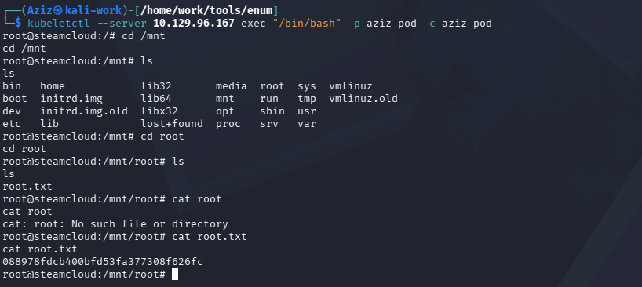 Root read directly off the node through the malicious pod's host-filesystem mount.
Epsilon. 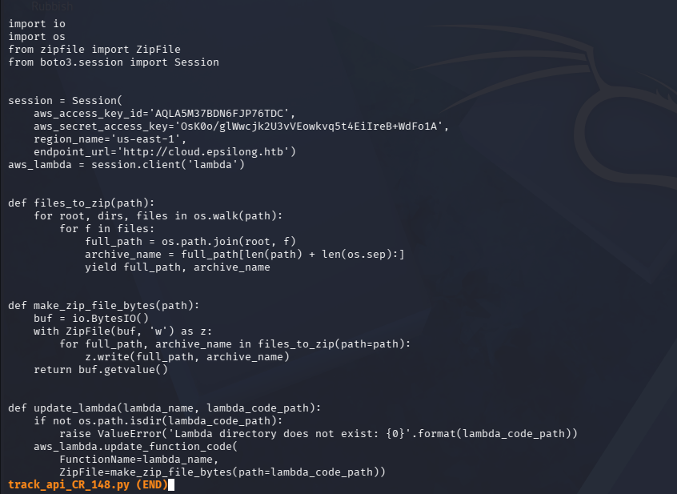 An earlier commit in the dumped .git history still holding the live AWS keys.
Gobox. 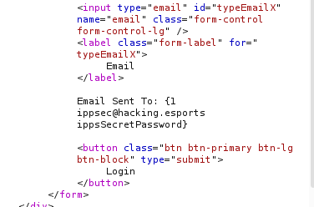 The Go template-injection payload dumping the full User object, email and password included.
Monteverde. 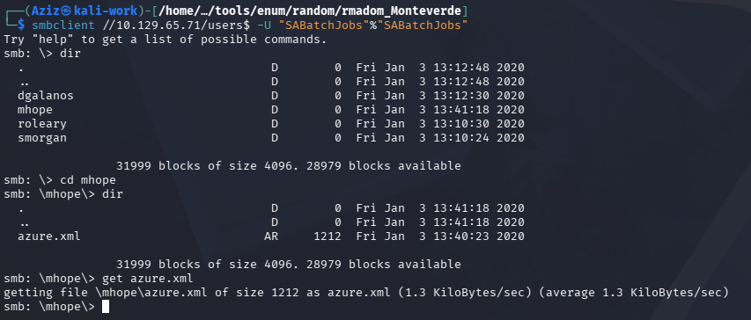 The readable users$ share, azure.xml pulled down with mhope's cleartext password inside.
Bucket. 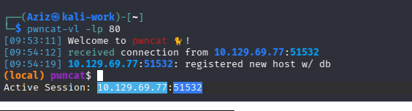 The uploaded PHP file triggered, the reverse shell landing as www-data.
Unobtainium. 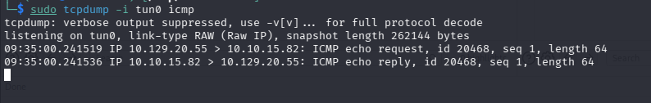 The command-injection payload executing, confirmed by the ICMP echo back at the listener.
Vessel. 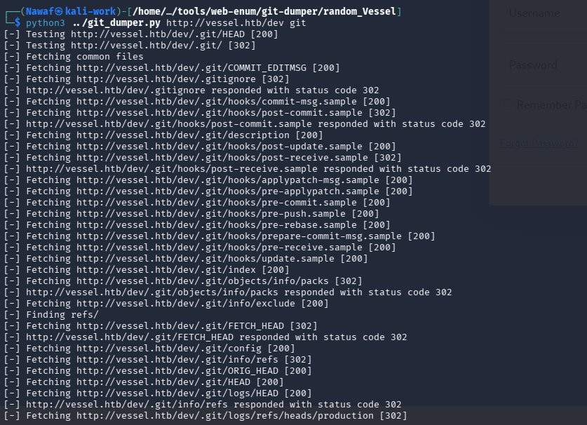 git-dumper reconstructing the exposed .git repository from the hidden /dev path.
Worker. 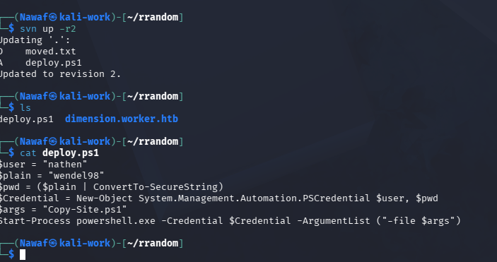 deploy.ps1, recovered from an old SVN revision, holding the hardcoded deployment credentials.
SnapVault is the project's centrepiece evidence, because it is where every one of those lessons is implemented and then proven under an identical attack rather than only described. The vulnerable build fell end to end. The frontend app.js leaked a read-only MinIO key, that key listed the bucket and, through an over-broad ListBucketVersions permission, recovered an old config.bak version still holding admin credentials, those credentials wrote a PHP webshell into the bucket, and the app's own mirror-to-web-root behaviour ran it, returning uid=33(www-data). All five steps were captured with command output and screenshots. Against the hardened build the same sequence stops at step one, with no key to harvest, confirmed by nmap showing MinIO no longer reachable from the host and feroxbuster finding only index.php and upload.php.
The agent run is the last piece of evidence and the quickest. Locked to loopback by its own hard safety rail, it replayed the full six-step chain unattended, finishing the compromise on the vulnerable build in about two minutes and confirming uid=33(www-data), in line with the manual run. On the hardened build it was stopped at the same first step a human tester hit. That match between manual testing and autonomous replay is part of the evidence in its own right, since it shows the finding is not an artefact of how hard a human poked at the build but a property of the configuration.

11. Testing, Validation, and Evaluation
The evaluation method is reproduction, not inspection. Instead of arguing from the code that a control should work, every control is tested by running the exact attack it is meant to stop and recording whether it does.
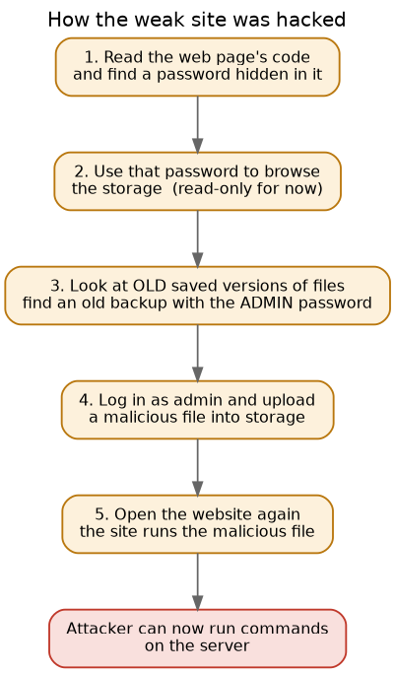
Each step of the chain was checked against both builds and against a named control.
Step | Attacker action | Vulnerable | Hardened, stopped by
1. Get a key | Read app.js for a hardcoded credential | Succeeds | C1, no key in the page
2. Enumerate | List the bucket with the leaked key | Succeeds (read-only) | n/a, nothing to find
3. Versioning leak | List and recover an old object version | Recovers admin creds | C3, versioning off, no secret stored
4. Write the webshell | Use recovered creds to write to the bucket | Succeeds | C4, scoped key cannot write an exec path
5. Trigger and RCE | Load the mirrored shell and run a command | uid=33(www-data) | C5, never mirrored or executed
6. Escalate | Attempt further privilege as the compromised process | Would land as root in a real deployment | C6, non-root, capabilities dropped
Two metrics mattered most. Detection and reproducibility, whether the same chain, run twice by two different actors, a human tester and the agent, gave the same outcome on each build. It did. Both runs ended in uid=33(www-data) on the vulnerable build and a block at step one on the hardened build, which rules out operator skill as the variable. The second was time to compromise, since speed is part of the risk argument in Section 2. The agent finished the full chain in about two minutes on the vulnerable build. Industry data puts similar cloud-credential attacks in the same range. Sysdig's 2023 Global Cloud Threat Report found that targeted cloud attacks typically run from credential discovery to completion in about ten minutes, and Anthropic's November 2025 disclosure of a state-linked campaign found that an AI agent, not a human operator, handled roughly 80 to 90 percent of the attack's reconnaissance, exploitation, and data collection once a human set the initial target. Together these support treating fast, automation-driven compromise as a current risk for this class of misconfiguration rather than a
theoretical one.
The clearest validation of the guideline itself is structural rather than numeric. Every one of the seven controls has at least one HTB machine behind it, in Section 10's table, and at least one attack step it visibly blocks, in the table above, so no control is a recommendation without a tested failure mode it closes.

12. Deployment, Operation, and Maintenance Considerations
The guideline is built to be shared across roles, since no single person on a real team owns all seven controls. Developers own the application-level ones, no secrets in the page, a least-privilege app key, an upload allow-list, and files that are streamed rather than executed, which are C1, C2, C4, and C5. Cloud and DevOps engineers own the infrastructure ones, object versioning and storage configuration plus container and runtime hardening, which are C3 and C6. Security reviewers own confirming that secrets stay out of version control, C7, and signing off before a team calls an environment hardened, rather than letting any one developer self-certify their own code.
Adopting the guideline in a real deployment means testing each control on its own rather than assuming an attack blocked at an early step proves every later one holds, since a chain that dies at step one tells a team nothing about whether step four would have survived. Each check is written to run with harmless test files and controlled accounts, with the expected result, the actual result, and the evidence recorded against the control's ID, the same discipline this report applies to SnapVault.
Maintenance is not a one-time pass. A key that was ever exposed, even briefly, should be treated as compromised and rotated rather than trusted again once it is out of view. Dependencies, base images, and web-server modules need regular updates, since an outdated component carries known attack chains even when every control above is otherwise met, which is exactly the pattern behind Worker's privileged build agent and Vessel's unpatched component. Logging across the authentication, storage, application, and pipeline layers should stay clear of secrets while still catching repeated failed logins, unusual downloads, and privileged changes, with a written process for isolating a compromised workload and revoking its credentials rather than improvising one mid-incident.
Communication matters as much as the technical checks. A control that fails in testing should raise a ticket against its ID, not an informal message that gets lost, so the fix and the retest both stay traceable later. A team picking this guideline up fresh should start with C1 and C7, since secrets left in client code or in git history are both the cheapest checks to run and, going by Section 10's evidence, the most common root cause across the eight machines.

13. Limitations and Future Improvement
The clearest limitation is scale. SnapVault is one small application on one Docker Compose host, not a managed cloud account with a full IAM system, many services, and real organisational scale, so the identity and permission findings stand in for a real cloud environment in simplified form rather than demonstrating one in full. The agent is hard-locked to loopback by design, which is right for safety but means it has only ever been run against our own two local builds, not the wider spread of misconfigurations a real target would present. The agent also carries one limitation worth naming outright. Anthropic's account of the GTG-1002 campaign noted that Claude hallucinated during parts of that operation, inventing findings that a human operator had to validate, which Anthropic called an obstacle to fully autonomous attacks. Our agent is narrower than that campaign, replaying one documented chain rather than improvising a new one, which cuts the room for that kind of fabrication, but the same caution holds. Its transcript is evidence to be checked, not a result to be trusted blindly, which is why Section 10's findings are cross-checked against the manual run rather than taken from the agent alone.
Testing was also held to the specific attack chain we built rather than an open-ended assessment. The hardened build is proven against this one chain, not against every possible path, and a determined tester with more time could reasonably hunt for weaknesses the eight-machine track did not happen to cover. Time and team size were real constraints too, three students across about fourteen weeks alongside other subjects, which shaped how far the guideline's supporting practices, patching, monitoring, and pipeline security, could go next to the seven core controls.
The most direct next step, already scoped in our project plan but outside this portfolio, is a developer-facing version of the agent. Instead of demonstrating a chain against our own lab, it would run the same class of checks against a developer's own cloud storage service and report back where it is exposed, turning the project from a demonstration into a tool a team could run before an attacker does. Beyond that, a natural second phase would extend the track and the guideline to cover identity-provider misconfigurations more deeply, given how often SnapVault and the eight machines both turned on a credential problem rather than a pure code flaw.

14. Conclusion
The project set out to show that cloud compromise usually comes from a short chain of ordinary mistakes rather than one sophisticated exploit, and to turn eight separate demonstrations of that pattern into something a developer can act on. All eight Cloud Exploitation machines are complete, each with a documented root cause and fix. SnapVault proves the pattern directly, with the same attack reaching full compromise on a weak configuration and stopping at the first move on a hardened one, checked by hand and by an agent running unattended in about two minutes. The seven-control guideline is the lasting output, the one artefact built to outlive this track and travel into a real codebase.
The value of the work is in that connection, from a specific HTB machine, to a general root cause, to a testable control, to evidence that the control holds. Capital One's 2019 breach showed what happens when that chain runs unchecked in production. Our contribution is a repeatable, evidence-backed way to check it before it does.
For the three of us, the lasting outcome is as much in how we now read a cloud architecture as in what we handed in. Eight machines later, a hardcoded key or an over-broad bucket policy reads less like a trivia answer and more like the first domino in a chain we can now name end to end, which is the habit of mind this track and this report were meant to leave us with.

15. References
- Vaas, L. (2019). Capital One hacked via misconfigured firewall, 100+ million clients affected. Sophos Naked Security.
- Krebs, B. (2019). What We Can Learn from the Capital One Hack. KrebsOnSecurity.
- Sysdig (2023). 2023 Global Cloud Threat Report. Sysdig Threat Research Team.
- Anthropic (2025). Disrupting the first reported AI-orchestrated cyber espionage campaign. Anthropic.
- Hack The Box. Cloud Exploitation track machines: SteamCloud, Epsilon, Gobox, Bucket, Worker, Monteverde, Vessel, Unobtainium.
- Team walkthroughs and build artefacts held alongside this report: the eight machine walkthroughs, the SnapVault Attack Walkthrough, the SnapVault Environment Comparison, and the Secure Cloud Environment Developer Guideline (SnapVault project team, 2026).

